***PROJECT***

***OBJECT ORIENTED PROGRAMMING CS-103***

***DR. NOUMAN RIAZ***

**Submitted By**

**Roll Numbers       Names**

**19011519-027       Muhammad Saqib**

**19011519-015       Zunair Ahmad**

**19011519-024       Sidra Naseem**

**19011519-037       Arooj Saghar**

**19011519-131       Syeda Umme Pakiza Imran**

**18321519-010       Afia Habib**

**Section CS-II-19-A**

Application Starts without any error

But if you want to use RestServices you have to @RestController annotation

And

if you want to use WebServices you have to @Controller annotation

code crashes with both annotations used at the same time

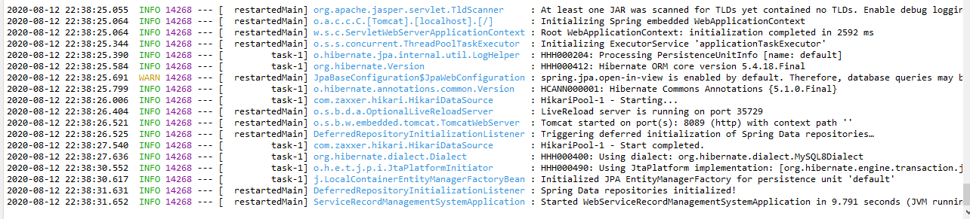

1. Home page

You can access all the links from the horizontal menu on the top

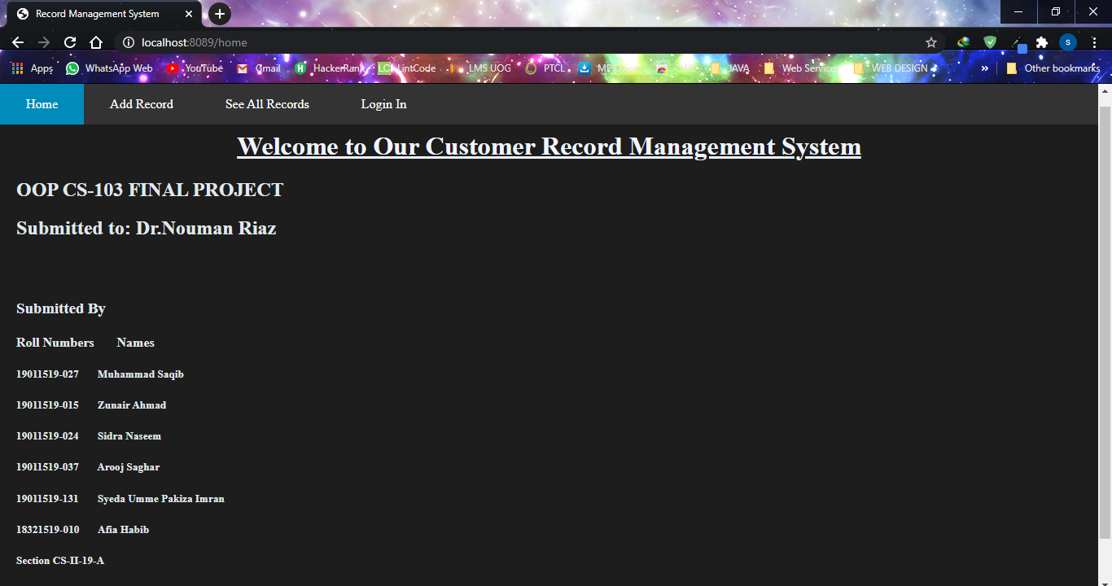

2.Image when adding a new record

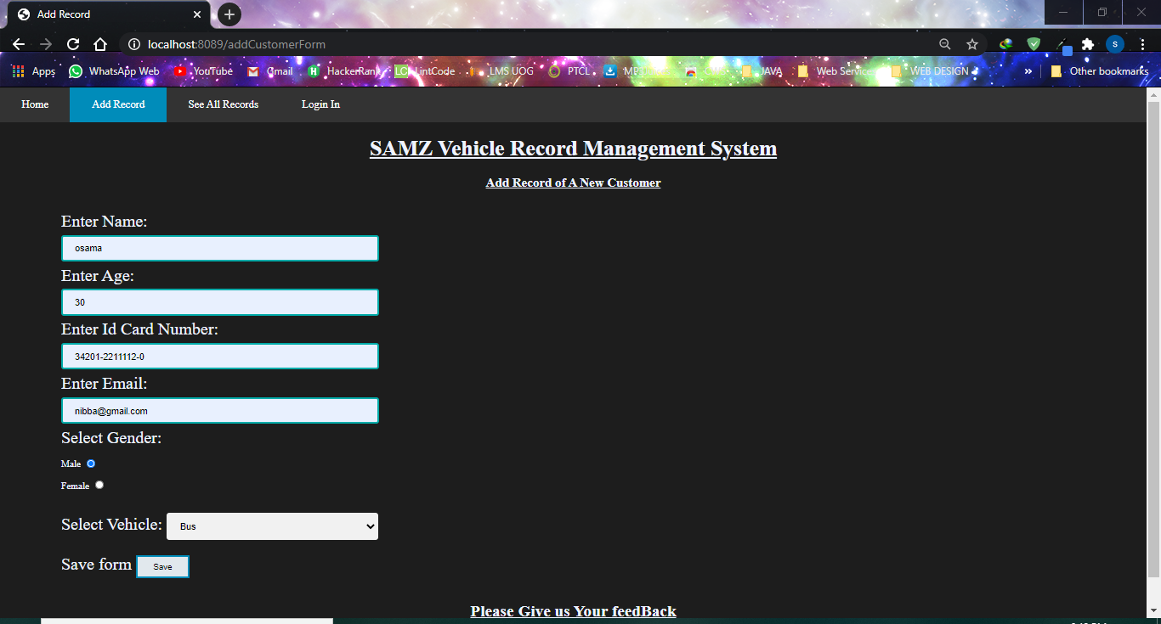

With post man -PostRequest

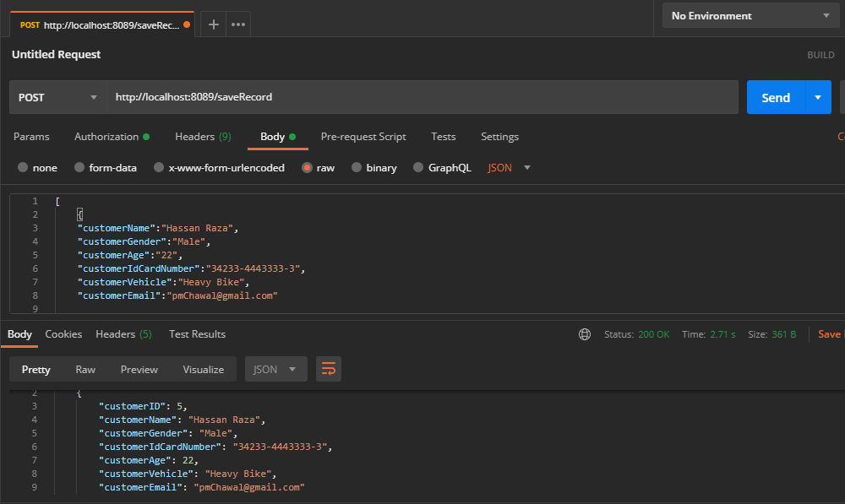

1. Displaying all the records

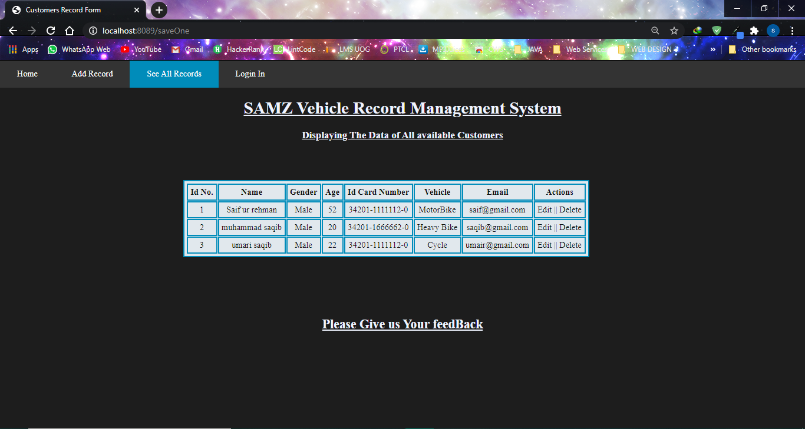

With postman -GetRequest

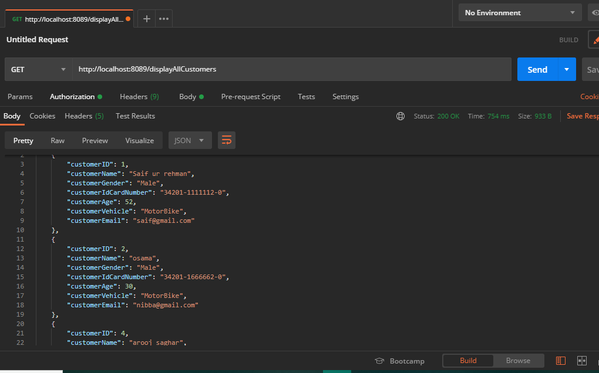

1. Updating a Record

To update click on the “edit” button in the actions table to update that record

You can see that the record at the ID 2 has been updated

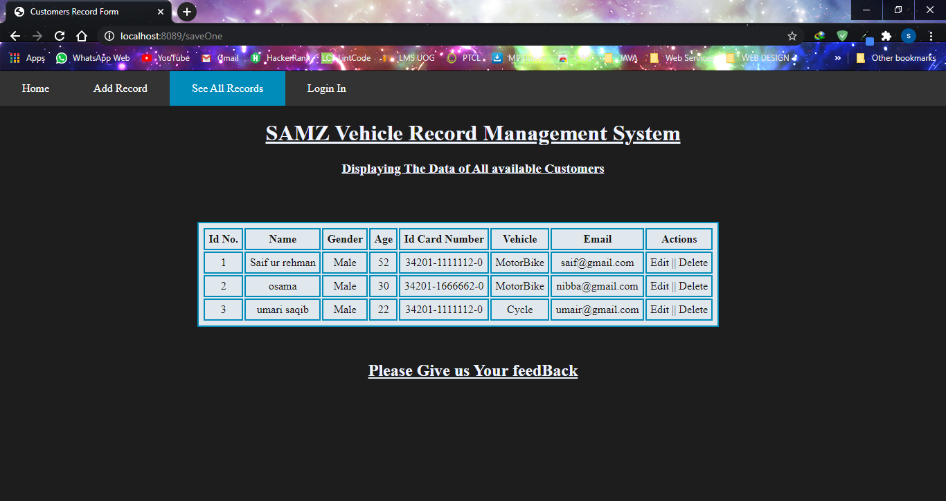

With postman -PutMapping

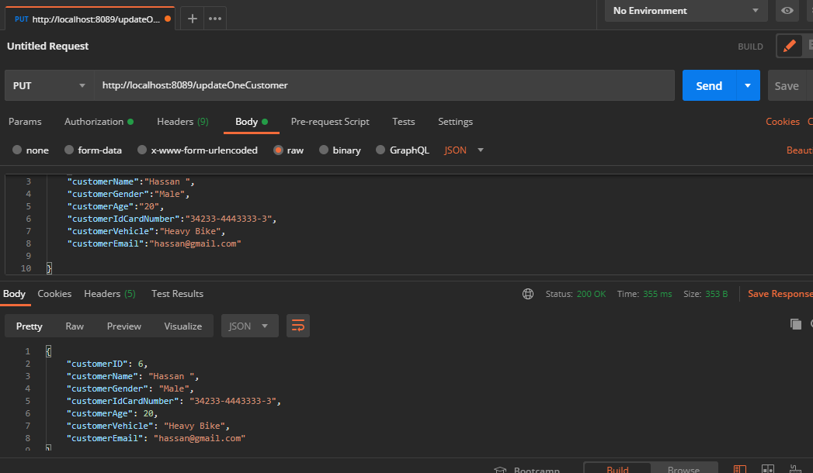

1. Deleting a record

To update click on the “delete” button in the actions table to delete that record

Record with ID 3 has been deleted

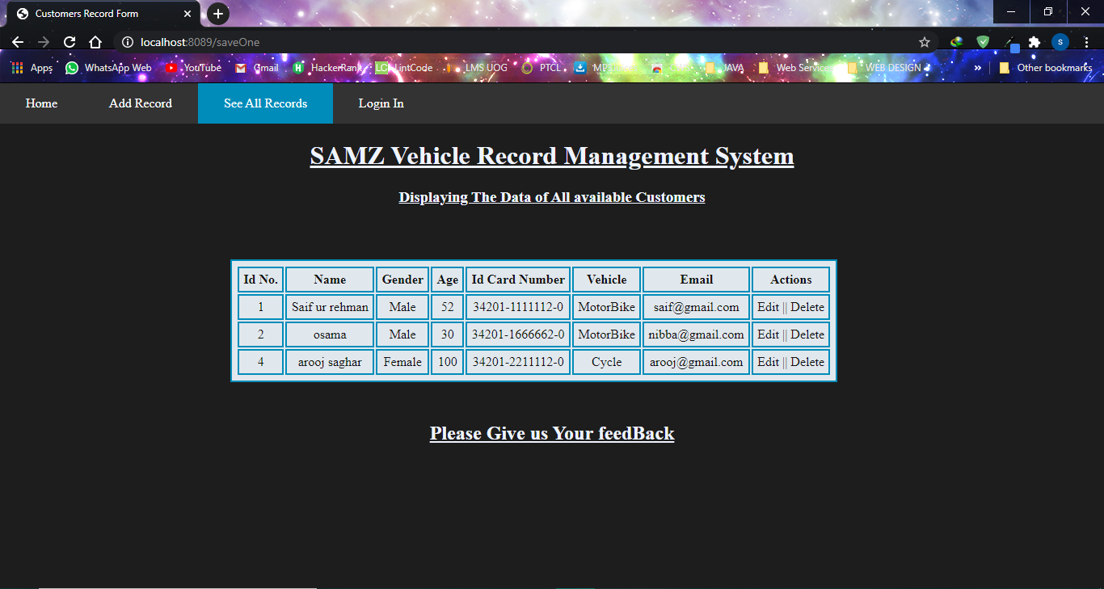

With postman -DeleteMapping

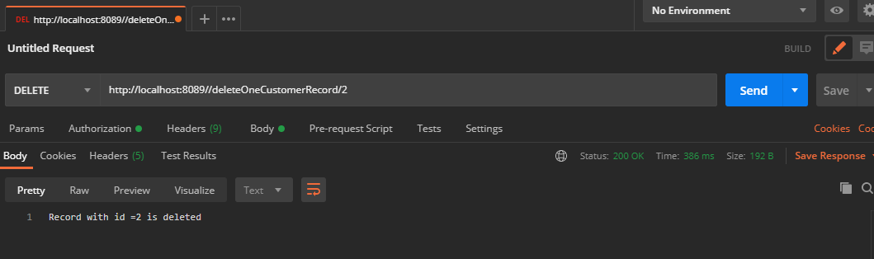

No id=2 record because it is deleted